Nithin S
221IT085

IT250 Lab Assignment 4

Q1) To Recognize different tokens in the given input file : Keywords, Identifiers, Constants, Operators and Punctuations

CODE

Note: This code takes file name as command line argument

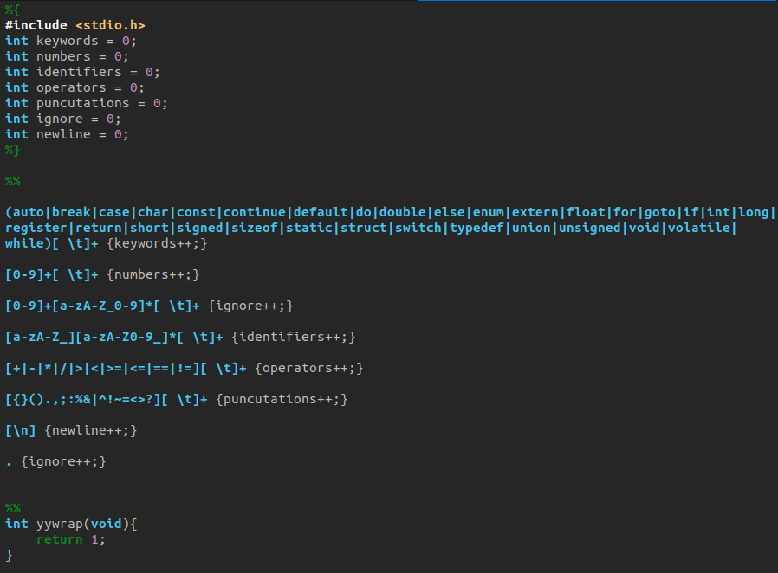

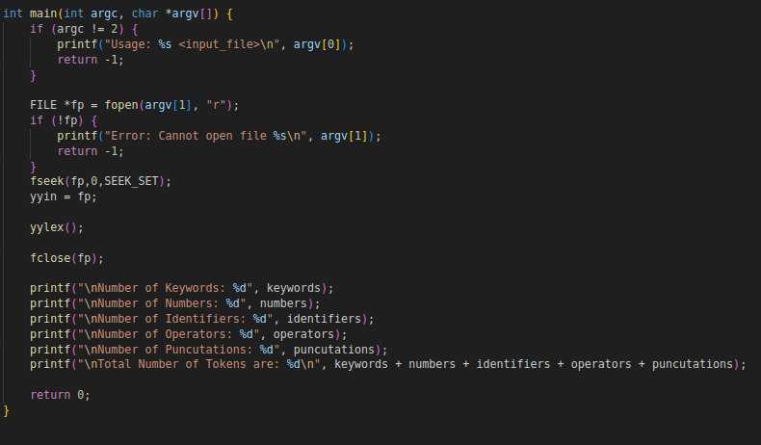

OUTPUT

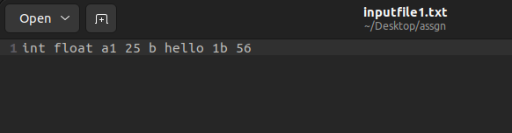

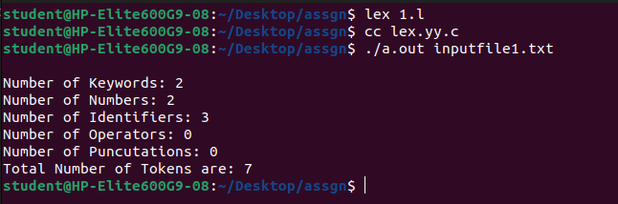

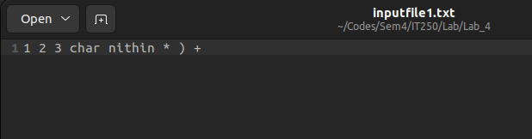

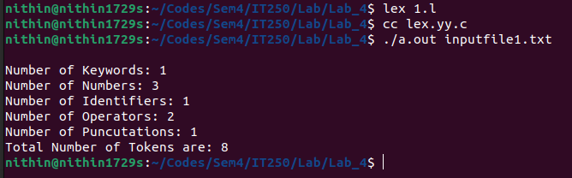

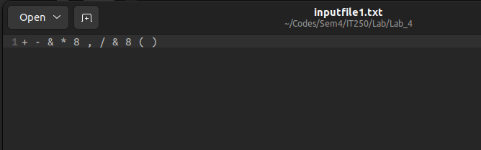

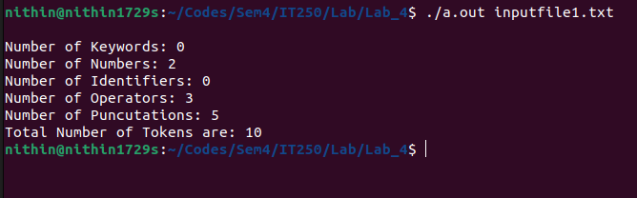

Q2) A new video about the recent developments in coding has been published on social media. After some
time, it is seen that there are N comments added. Now from N comments the admin wants to know
count C - the occurrences of the keyword K. He needs your help to find the value of C.

CODE
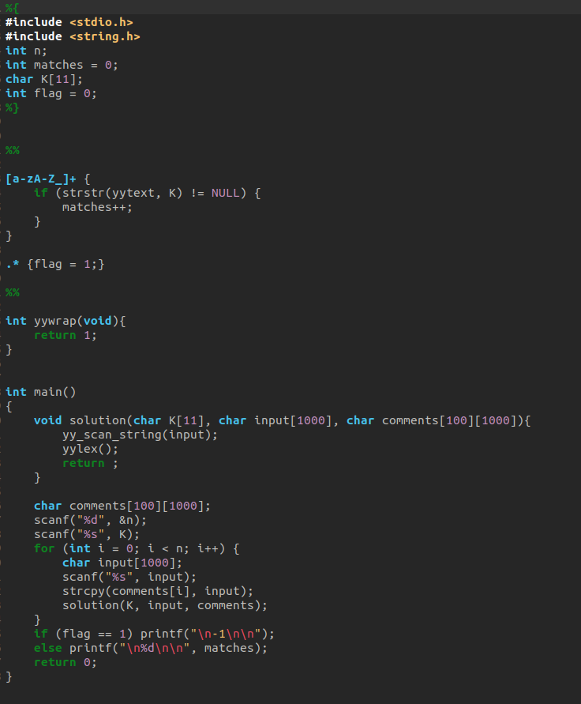

OUTPUT

